COP6726 – Database System Implementation

Project 5 – Report

**Team members:**

1. Akshay Ganapathy (UFID: 3684-6922)
2. Riyaz Shaik (UFID: 4360-0170)

**Project Demo video included inside the zip file.**

**Steps to execute project code:**

The code was executed using **Windows Subsystem for Linux (Ubuntu 18.04)** environment.

1. The project source code is in the folder “a5-test”. Its contents include the following:
   1. Code needed to run main.cc.
   2. All “.bin” and “.meta” files included in the “a5-test” folder.
   3. Google test framework has been added in the directory “googletest”. This framework is needed to run gtest unit test cases.
   4. All the gtest unit test cases have been added in “a5-test” folder.
   5. Makefile to compile main.cc and gtest unit test cases.
2. To run main.cc, from project root execute command “make a5.out”. Run a5.out by command “./a5.out” followed by list of commands:

1. Fireup the database: It starts the database

2. Enter your CNF: It is used to enter the query we want to execute

3. Close the database: It stops the database

1. To run gtest unit test cases, from project root execute command “make gtest.out” and then execute “./gtest.out”.

**The following are the methods with their description:**

|  |  |
| --- | --- |
| **Method** | **Description** |
| bool createTable(); | This function is used to create a table if it does not exist by taking attributes and type as input. Using those values table is created and Boolean value true is returned. If table already exists Boolean value false is returned meaning that the table already exists. |
| bool insertInto(); | This function is used for loading data into a table using the file specified. It is mainly used for loading data in bulk from the file. It returns true if data is loaded successfully and returns false if data loading fails |
| bool dropTable(); | This function is used to remove table and delete the binary file respectively. It returns true if drop is successful and false if dropping table failed |
| bool exists(); | This function is used to check if a relation in all lines of file read. It returns true if a relation exists and  false otherwise. |
| void run(); | This function is called by a5main.cc. It is used to create the  Queryops and QueryPlan objects. It takes the user input about  action to be performed such as fire up the database, execute a cnf  or close the database and calls the corresponding functions to  perform the specified operation. |
| void clear(); | This function is used to clear all the variables and lists used for an operation and to remove all the temporary files. |
| void setOutput(char* out); | This function in used to specify the location where the result of an operation is to be directed. It usually one of “STDOUT”, “FILE” or “NONE”. |

**The following are the screenshots of the output:**

1. Query 1: SELECT n.n_nationkey FROM nation AS n WHERE (n.n_name = 'UNITED STATES');

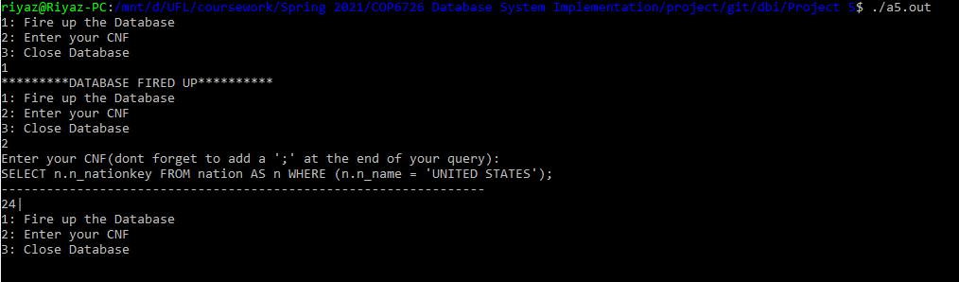

2. Query 2: SELECT n.n_name FROM nation AS n, region AS r WHERE (n.n_regionkey = r.r_regionkey) AND (n.n_nationkey > 5);

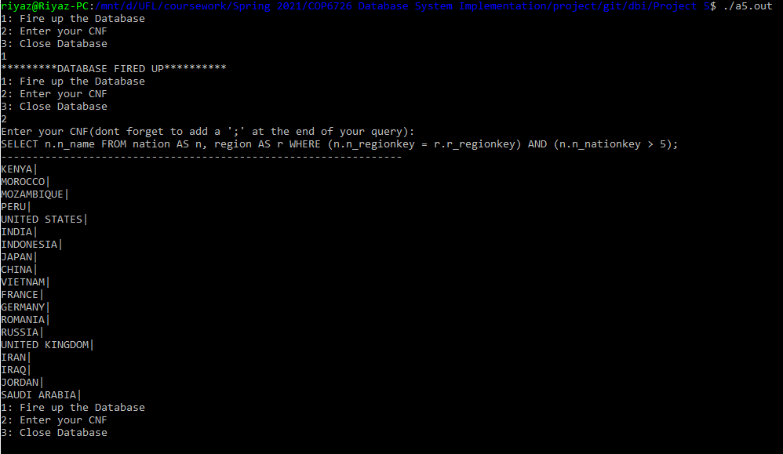

3. Query 3: SELECT SUM (n.n_nationkey) FROM nation AS n, region AS r WHERE (n.n_regionkey = r.r_regionkey) AND (n.n_name = 'UNITED STATES');

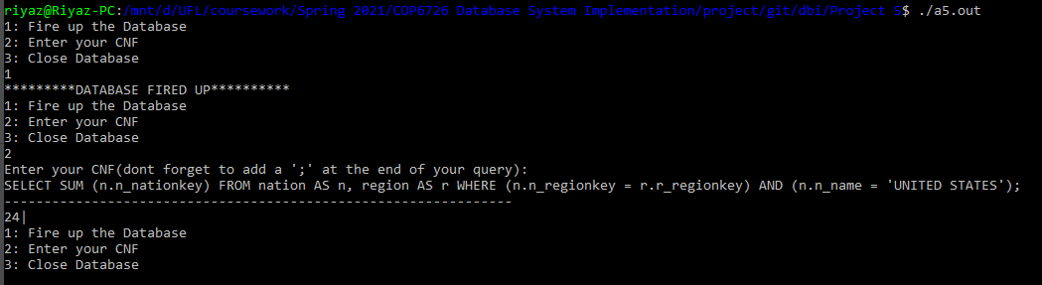

4. Query 4: SELECT SUM (n.n_regionkey) FROM nation AS n, region AS r WHERE (n.n_regionkey = r.r_regionkey) AND (n.n_name = 'UNITED STATES') GROUP BY n.n_regionkey;

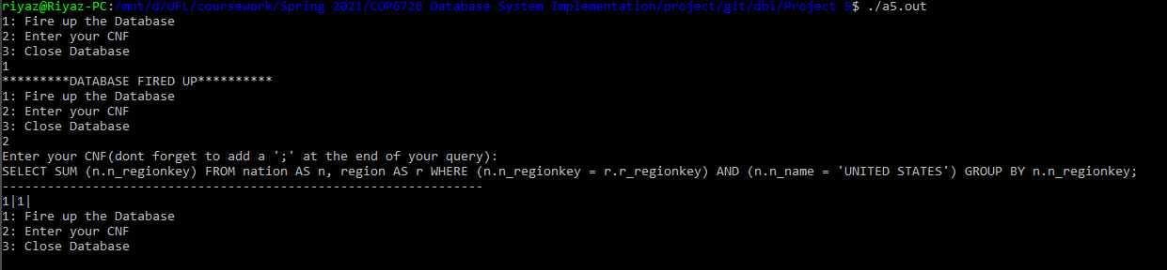

5. Query 5: SELECT SUM DISTINCT (n.n_nationkey + r.r_regionkey) FROM nation AS n, region AS r, customer AS c WHERE (n.n_regionkey = r.r_regionkey) AND (n.n_nationkey = c.c_nationkey) AND (n.n_nationkey > 10) GROUP BY r.r_regionkey;

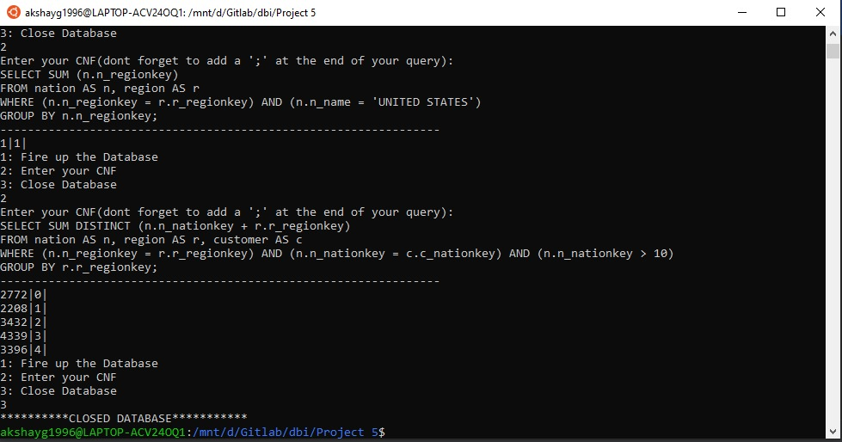

6. Create Table for HEAP Data: CREATE TABLE test_table (id INTEGER, name STRING) AS HEAP;

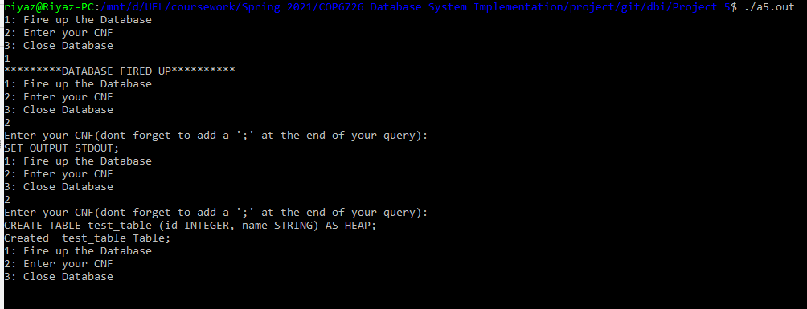

7. Insert: INSERT 'file.txt' INTO test_table;

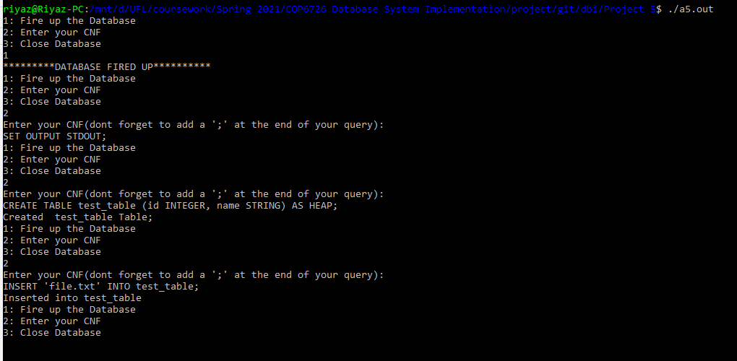

8. Drop Table: DROP TABLE test_table;

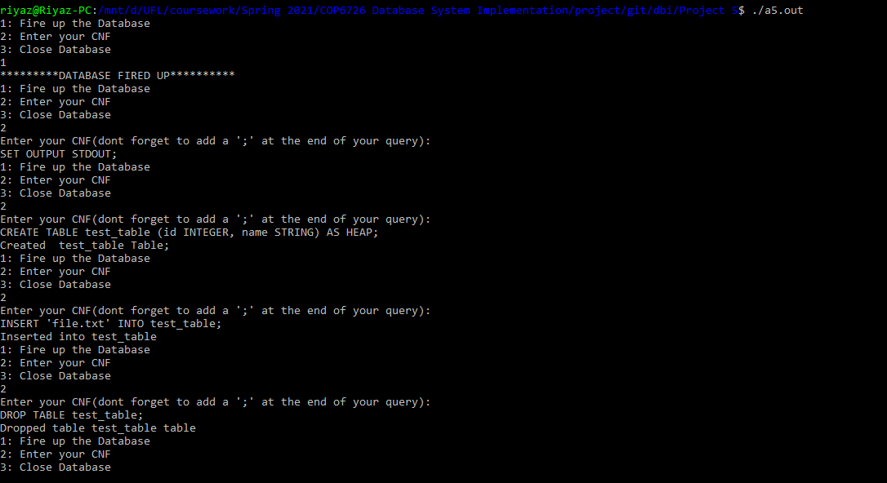

9. Create Table for SORTED Data: CREATE TABLE test_table (id INTEGER, name STRING) AS SORTED ON id,name;

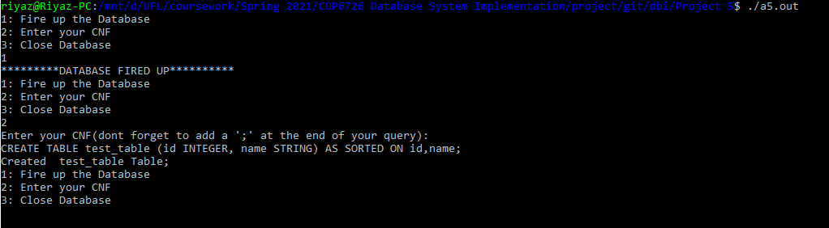

**The following are the results of gtest unit test cases:**

**Result:** All the unit test cases passed

